**REGULAR MEETING**

**COUNCIL OF THE CITY OF MONTGOMERY**

**SEPTEMBER 6, 2016 – 5:00 P.M.**

**The Council met in regular session on Tuesday, September 6, 2016, at 5:00 p.m., in the Council Auditorium, City Hall, with the follow­ing members present:**

**PRESENT: BOLLINGER, LYONS, LARKIN, GREEN,**

**BELL, LEE, PRUITT, JINRIGHT --8**

**ABSENT: BURKETTE --1**

**President Charles Jinright presid­ed as Chairman of the meeting, and Brenda Gale Blalock, City Clerk, served as the Clerk of the meeting. The meeting was opened with the invocation by Councillor Bollinger and the Pledge of Allegiance.**

**Councillor Larkin made a motion to adopt the August 16, 2016, Work Session Minutes, as circulated, which motion carried with the following vote:**

**AYES: BOLLINGER, LARKIN, GREEN,**

**BELL, LEE, JINRIGHT --6**

**NAYS: NONE --0**

**ABSTAINED: LYONS, PRUITT --2**

**ABSENT: BURKETTE --1**

**Councillor Larkin made a motion to adopt the August 16, 2016, Regular Council Minutes, as circulated, which motion carried with the following vote:**

**AYES: BOLLINGER, LARKIN, GREEN,**

**BELL, LEE, PRUITT, JINRIGHT --7**

**NAYS: NONE --0**

**ABSTAINED: LYONS --1**

**ABSENT: BURKETTE --1**

**The Clerk stated she was in receipt of the following Mayoral Veto of Resolution No. 155-2016. The reason for the veto is: inspections are complete and license issued.**

**RESOLUTION NO. 155-2016**

**A RESOLUTION DENYING AND/OR REVOKING RIGHT**

**TO OPERATE A BUSINESS FOR FAILURE**

**TO PURCHASE BUSINESS LICENSE**

**WHEREAS, the City Council of the City of Montgomery has authorized and approved the issuance of business licenses and collection of taxes for businesses in the City of Montgomery and Police Jurisdiction; and**

**WHEREAS, Jahee Bae, d/b/a Midori Restaurant, 5824 Woodmere Boulevard, Montgomery, AL 36117, has been advised they are in violation of the Montgomery City Code of Ordinances for failure to purchase business license; and**

**WHEREAS, Jahee Bae, d/b/a Midori Restaurant, 5824 Woodmere Boulevard, Montgomery, AL 36117, continues to operate the business without purchase of a business license or otherwise complying with Chapter 16 of the City of Montgomery Code of Ordinances; and**

**WHEREAS, the City Council desires to deny and/or revoke Jahee Bae, d/b/a Midori Restaurant, 5824 Woodmere Boulevard, Montgomery, AL 36117, the right to operate a business in the City of Montgomery and authorizes the Finance Department to close the business:**

**NOW, THEREFORE, BE IT RESOLVED BY THE COUNCIL OF THE CITY OF MONTGOMERY, ALABAMA, that the City Council denies and/or revokes Jahee Bae, d/b/a Midori Restaurant, 5824 Woodmere Boulevard, Montgomery, AL 36117, the right to operate a business in the City of Montgomery and authorizes the Finance Department to close the business. The owner/proprietor of the business must appear before the City Council prior to the issuing of any future business license.**

**Councillor Larkin made a motion to sustain the Mayor’s Veto, which motion carried with the following vote:**

**AYES: BOLLINGER, LYONS, LARKIN, GREEN,**

**BELL, LEE, PRUITT, JINRIGHT --8**

**NAYS: NONE --0**

**ABSTAINED: NONE --0**

**ABSENT: BURKETTE --1**

**The Clerk stated this was the time and place to hear and consider all objections and protests the following proposed ordinance:**

**ORDINANCE NO. 34-2016**

**BE IT ORDAINED BY THE COUNCIL OF THE CITY OF MONTGOMERY, ALABAMA as follows:**

**SECTION 1. That the Zoning Ordinance of Montgomery, Alabama, adopted September 17, 1963, be amended by removing the following described property from an AGR-1 (Residential Agriculture) Zoning District to a B-2 (Commercial) Zoning District.**

**Commence at the northeast corner of Section 30, T15N, R18E Montgomery County, Alabama and run south 4,794 ft.; thence west 1,254.74 ft. to a point on the west right-of-way of Snowdoun Chambers Road and being the point of beginning; thence along said west right-of-way S36°59’06”W, 331.92 ft. to an existing right-of-way monument; thence along the flared right-of-way between Snowdoun Chambers Road and Hobbie Road S50°09’10”W 161.72 ft. to a point on the north right-of-way of Hobbie Road; thence along said north right-of-way N88°46’16”W, 85.50 ft. to a point on a flared right-of-way between Hobbie Road and US Highway 331; thence along said flared right-of-way N63°01’28”W 318 ft. to a point on the east right-of-way of US Highway 331; thence along said east right-of-way N18°30’04”W, 209.43 ft.; thence leaving said east right-of-way N86°24’14”E, 728.34 ft.; thence S56°11’14”E, 38.85 ft. to the point of beginning. All lying in the SE ¼ of Section 30, T15N, R18E Montgomery County, Alabama and containing 4.33 acres more or less.**

**SECTION 2. This ordinance shall take effect upon its passage, approval and publication, or as otherwise provided by law.**

**Mr. Tommy Tyson was present representing the Planning Commission. No one was present representing this item. No one was present in opposition of this item.**

**Councillor Green made the motion to sustain the recommendation of the Planning Commission and adopt the foregoing ordinance, which motion carried with the following vote:**

**AYES: BOLLINGER, LYONS, LARKIN, GREEN,**

**BELL, LEE, PRUITT, JINRIGHT --8**

**NAYS: NONE --0**

**ABSTAINED: NONE --0**

**ABSENT: BURKETTE --1**

**The Clerk stated this was the time and place for the public hearing on the proposed ordinance amending FY 2016 Operating and Debt Service Budget and adopting FY 2017 Operating and Debt Service Budget. No one was present in support or opposition of this item. The Chairman declared that the public hearing was closed.**

**The Clerk stated this was the time and place to hear and consider the following proposed ordinance:**

**LEFT BLANK INTENTIONALLY**

**It was the consensus of the Council to carry this item over to the next regular council meeting. The Chairman scheduled a Budget Work Session for September 13, 2016, at 3:00 p.m., in the Old Council Chamber.**

**The Clerk stated this was the time and place to hear and consider the following proposed resolution:**

**RESOLUTION NO. ________________**

**WHEREAS, the Ad Hoc Committee on Magnet Schools has met and recommended the contracting of a liaison consultant between the City of Montgomery and the Montgomery Public Schools for the purpose of helping expand the Magnet Program:**

**WHEREAS, said committee is recommending that a contract be given to Mary George Jester as said contract liaison consultant for a salary of $30,000.**

**NOW, THEREFORE, BE IT RESOLVED BY THE COUNCIL OF THE CITY OF MONTGOMERY, ALABAMA, concurs in the issuing of a contract to Mary George Jester to serve as a contract liaison consultant for the salary of $30,000 for the purpose of helping the City of Montgomery and the Montgomery Public School System expand the Magnet Program.**

**Councillor Pruitt made a motion to suspend the rules in order that the foregoing resolution could be placed upon its final passage, which motion was defeated by the following vote; therefore, tabling this item until the next regular meeting:**

**AYES: BOLLINGER, LYONS, LARKIN,**

**GREEN, LEE, PRUITT, JINRIGHT --7**

**NAYS: BELL --1**

**ABSTAINED: NONE --0**

**ABSENT: BURKETTE --1**

**The Clerk stated this was the time and place to hear and consider all objections and protests to the following proposed resolution:**

**RESOLUTION NO. 163-2016**

**WHEREAS, Whole Foods Market Group, Inc., d/b/a Whole Foods Market, 1450 Taylor Road, has filed an application for Retail Beer (On or Off Premises) and Retail Table Wine (On or Off Premises) Licenses, as indicated on the application form of the State of Alabama Alcoholic Beverage Control Board:**

**NOW, THEREFORE, BE IT RESOLVED BY THE COUNCIL OF THE CITY OF MONTGOMERY, ALABAMA, Whole Foods Market Group, Inc., d/b/a Whole Foods Market, 1450 Taylor Road, be and is hereby approved for Retail Beer (On or Off Premises) and Retail Table Wine (On or Off Premises) Licenses, and concurrence in the issuance of the licenses by the State of Alabama Alcoholic Beverage Control Board.**

**Mr. Chris Gonzales was present representing this item. No one was present in opposition to this item.**

**Councillor Larkin made a motion to suspend the rules in order that the foregoing resolution could be placed upon its final passage, which motion carried with the following vote:**

**AYES: BOLLINGER, LYONS, LARKIN, GREEN,**

**BELL, LEE, PRUITT, JINRIGHT --8**

**NAYS: NONE --0**

**ABSTAINED: NONE --0**

**ABSENT: BURKETTE --1**

**The rules having been suspended, Councillor Larkin made a motion to adopt the foregoing resolution, which motion carried with the following vote:**

**AYES: BOLLINGER, LYONS, LARKIN, GREEN,**

**BELL, LEE, PRUITT, JINRIGHT --8**

**NAYS: NONE --0**

**ABSTAINED: NONE --0**

**ABSENT: BURKETTE --1**

**The Clerk stated this was the time and place to hear and consider all objections and protests to the following proposed resolution:**

**RESOLUTION NO. 164-2016**

**WHEREAS, Wharf Casual Seafood Montgomery Inc., d/b/a Wharf Casual Seafood, 3954 Atlanta Highway, has filed an application for Retail Beer (On or Off Premises) and Retail Table Wine (On or Off Premises) Licenses, as indicated on the application form of the State of Alabama Alcoholic Beverage Control Board:**

**NOW, THEREFORE, BE IT RESOLVED BY THE COUNCIL OF THE CITY OF MONTGOMERY, ALABAMA, Wharf Casual Seafood Montgomery Inc., d/b/a Wharf Casual Seafood, 3954 Atlanta Highway, be and is hereby approved for Retail Beer (On or Off Premises Only) and Retail Table Wine (On or Off Premises Only) Licenses, and concurrence in the issuance of the licenses by the State of Alabama Alcoholic Beverage Control Board.**

**Mr. Noah Griggs was present representing this item. No one was present in opposition to this item.**

**Councillor Bollinger made a motion to suspend the rules in order that the foregoing resolution could be placed upon its final passage, which motion carried with the following vote:**

**AYES: BOLLINGER, LYONS, LARKIN, GREEN,**

**BELL, LEE, PRUITT, JINRIGHT --8**

**NAYS: NONE --0**

**ABSTAINED: NONE --0**

**ABSENT: BURKETTE --1**

**The rules having been suspended, Councillor Bollinger made a motion to adopt the foregoing resolution, which motion carried with the following vote:**

**AYES: BOLLINGER, LYONS, LARKIN, GREEN,**

**BELL, LEE, PRUITT, JINRIGHT --8**

**NAYS: NONE --0**

**ABSTAINED: NONE --0**

**ABSENT: BURKETTE --1**

**The Clerk stated this was the time and place to hear and consider all objections and protests to the following proposed resolution:**

**RESOLUTION NO. ____________**

**WHEREAS, DOLGENCORP LLC, d/b/a Dollar General Store 17102, 8990 Atlanta Highway, has filed an application for Retail Beer (Off Premises Only) and Retail Table Wine (Off Premises Only) Licenses, as indicated on the application form of the State of Alabama Alcoholic Beverage Control Board:**

**NOW, THEREFORE, BE IT RESOLVED BY THE COUNCIL OF THE CITY OF MONTGOMERY, ALABAMA, DOLGENCORP LLC, d/b/a Dollar General Store 17102, 8990 Atlanta Highway, be and is hereby approved for Retail Beer (Off Premises Only) and Retail Table Wine (Off Premises Only) Licenses, and concurrence in the issuance of the licenses by the State of Alabama Alcoholic Beverage Control Board.**

**Ms. Norma Rogers was present representing this item. No one was present in opposition to this item.**

**Councillor Bollinger requested this item be carried over to the next regular council meeting, which was the consensus of the Council.**

**The Clerk stated this was the time and place to hear and consider all objections and protests to the following proposed resolution:**

**RESOLUTION NO. 165-2016**

**WHEREAS, Montgomery Riverfront Development Foundation, d/b/a Zombie Walk 2016, 100 Block of Tallapoosa Street, has filed an application for a Non-Profit Tax Exempt Liquor License, as indicated on the application form of the State of Alabama Alcoholic Beverage Control Board:**

**NOW, THEREFORE, BE IT RESOLVED BY THE COUNCIL OF THE CITY OF MONTGOMERY, ALABAMA, Montgomery Riverfront Development Foundation, d/b/a Zombie Walk 2016, 100 Block of Tallapoosa Street, be and is hereby approved for a Non-Profit Tax Exempt Liquor License, and concurrence in the issuance of the license by the State of Alabama Alcoholic Beverage Control Board.**

**Ms. Jamie Gonzales was present representing this item. No one was present in opposition to this item.**

**Councillor Larkin made a motion to suspend the rules in order that the foregoing resolution could be placed upon its final passage, which motion carried with the following vote:**

**AYES: BOLLINGER, LYONS, LARKIN, GREEN,**

**BELL, LEE, PRUITT, JINRIGHT --8**

**NAYS: NONE --0**

**ABSTAINED: NONE --0**

**ABSENT: BURKETTE --1**

**The rules having been suspended, Councillor Larkin made a motion to adopt the foregoing resolution, which motion carried with the following vote:**

**AYES: BOLLINGER, LYONS, LARKIN, GREEN,**

**BELL, LEE, PRUITT, JINRIGHT --8**

**NAYS: NONE --0**

**ABSTAINED: NONE --0**

**ABSENT: BURKETTE --1**

**The Clerk stated this was the time and place to hear and consider the following proposed resolution:**

**RESOLUTION NO. 166-2016**

**WHEREAS, Paul Young, d/b/a Paul’s Taxi, 5760 Mt. Hebron Road, Eclectic, AL, has made application for a permit to operate a Taxicab Company in the City of Montgomery; and**

**WHEREAS, rules and regulations set out in Chapter 6 of the Code of Ordinances of the City of Montgomery have been complied with:**

**NOW, THEREFORE, BE IT RESOLVED BY THE COUNCIL OF THE CITY OF MONTGOMERY, ALABAMA, that Paul Young, d/b/a Paul’s Taxi, 5760 Mt. Hebron Road, Eclectic, AL, be and is hereby granted approval to operate a Taxicab company in the City of Montgomery.**

**Mr. Paul Young was present representing this item.**

**Councillor Bollinger made a motion to suspend the rules in order that the foregoing resolution could be placed upon its final passage, which motion carried with the following vote:**

**AYES: BOLLINGER, LYONS, LARKIN, GREEN,**

**BELL, LEE, PRUITT, JINRIGHT --8**

**NAYS: NONE --0**

**ABSTAINED: NONE --0**

**ABSENT: BURKETTE --1**

**The rules having been suspended, Councillor Bollinger made a motion to adopt the foregoing resolution, which motion carried with the following vote:**

**AYES: BOLLINGER, LYONS, LARKIN, GREEN,**

**BELL, LEE, PRUITT, JINRIGHT --8**

**NAYS: NONE --0**

**ABSTAINED: NONE --0**

**ABSENT: BURKETTE --1**

**The Clerk stated this was the time and place to hear and consider the following proposed resolution:**

**RESOLUTION NO. 167-2016**

**WHEREAS, Towaki Johnson, d/b/a Genesis Transport Service, 2835 Zelda Road, has made application for a permit to operate an Alternative Transportation Service in the City of Montgomery; and**

**WHEREAS, rules and regulations set out in Chapter 6 of the Code of Ordinances of the City of Montgomery have been complied with:**

**NOW, THEREFORE, BE IT RESOLVED BY THE COUNCIL OF THE CITY OF MONTGOMERY, ALABAMA, that Towaki Johnson, d/b/a Genesis Transport Service, 2835 Zelda Road, be and are hereby granted approval to operate an Alternative Transportation Service in the City of Montgomery.**

**Ms. Towaki Johnson was present representing this item.**

**Councillor Lee made a motion to suspend the rules in order that the foregoing resolution could be placed upon its final passage, which motion carried with the following vote:**

**AYES: BOLLINGER, LYONS, LARKIN, GREEN,**

**BELL, LEE, PRUITT, JINRIGHT --8**

**NAYS: NONE --0**

**ABSTAINED: NONE --0**

**ABSENT: BURKETTE --1**

**The rules having been suspended, Councillor Lee made a motion to adopt the foregoing resolution, which motion carried with the following vote:**

**AYES: BOLLINGER, LYONS, LARKIN, GREEN,**

**BELL, LEE, PRUITT, JINRIGHT --8**

**NAYS: NONE --0**

**ABSTAINED: NONE --0**

**ABSENT: BURKETTE --1**

**The Clerk stated this was the time and place to hear and consider the following proposed resolution:**

**RESOLUTION NO. 168-2016**

**WHEREAS, William Glenn Donald’s term on the Montgomery Historic Preservation Commission expired April 19, 2011; and**

**WHEREAS, Councillor Lyons has nominated Ken Ward to serve on said board:**

**NOW, THEREFORE, BE IT RESOLVED BY THE COUNCIL OF THE CITY OF MONTGOMERY, ALABAMA, that Ken Ward be and is hereby appointed to the Montgomery Historic Preservation Commission for a three-year term, with term ending April 19, 2017.**

**Councillor Lee made a motion to suspend the rules in order that the foregoing resolution could be placed upon its final passage, which motion carried with the following vote:**

**AYES: BOLLINGER, LYONS, LARKIN, GREEN,**

**BELL, LEE, PRUITT, JINRIGHT --8**

**NAYS: NONE --0**

**ABSTAINED: NONE --0**

**ABSENT: BURKETTE --1**

**The rules having been suspended, Councillor Lee made a motion to adopt the foregoing resolution, which motion carried with the following vote:**

**AYES: BOLLINGER, LYONS, LARKIN, GREEN,**

**BELL, LEE, PRUITT, JINRIGHT --8**

**NAYS: NONE --0**

**ABSTAINED: NONE --0**

**ABSENT: BURKETTE --1**

**The Clerk stated this was the time and place to hear and consider the following proposed resolution:**

**RESOLUTION NO. 169-2016**

**WHEREAS, Jerry Kyser’s term on the Montgomery Airport Authority expired March 21, 2016; and**

**WHEREAS, Councillor Lyons has requested that he continue to serve on said board:**

**NOW, THEREFORE, BE IT RESOLVED BY THE COUNCIL OF THE CITY OF MONTGOMERY, ALABAMA, that Jerry Kyser be and is hereby reappointed to the Montgomery Airport Authority for a four-year term, with term ending March 21, 2020.**

**Councillor Lyons made a motion to suspend the rules in order that the foregoing resolution could be placed upon its final passage, which motion carried with the following vote:**

**AYES: BOLLINGER, LYONS, LARKIN, GREEN,**

**BELL, LEE, PRUITT, JINRIGHT --8**

**NAYS: NONE --0**

**ABSTAINED: NONE --0**

**ABSENT: BURKETTE --1**

**The rules having been suspended, Councillor Lyons made a motion to adopt the foregoing resolution, which motion carried with the following vote:**

**AYES: BOLLINGER, LYONS, LARKIN, GREEN,**

**BELL, LEE, PRUITT, JINRIGHT --8**

**NAYS: NONE --0**

**ABSTAINED: NONE --0**

**ABSENT: BURKETTE --1**

**The Clerk stated this was the time and place to hear and consider the following proposed resolution:**

**RESOLUTION NO. 170-2016**

**WHEREAS, James D. Reynolds, Jr.’s term on the Montgomery Airport Authority expired March 21, 2016; and**

**WHEREAS, Councillor Lee has nominated Barry Harmon to serve on said board:**

**NOW, THEREFORE, BE IT RESOLVED BY THE COUNCIL OF THE CITY OF MONTGOMERY, ALABAMA, that Barry Harmon be and is hereby appointed to the Montgomery Airport Authority for a four-year term, with term ending March 21, 2020.**

**Councillor Lee made a motion to suspend the rules in order that the foregoing resolution could be placed upon its final passage, which motion carried with the following vote:**

**AYES: BOLLINGER, LYONS, LARKIN, GREEN,**

**BELL, LEE, PRUITT, JINRIGHT --8**

**NAYS: NONE --0**

**ABSTAINED: NONE --0**

**ABSENT: BURKETTE --1**

**The rules having been suspended, Councillor Lee made a motion to adopt the foregoing resolution, which motion carried with the following vote:**

**AYES: BOLLINGER, LYONS, LARKIN, GREEN,**

**BELL, LEE, PRUITT, JINRIGHT --8**

**NAYS: NONE --0**

**ABSTAINED: NONE --0**

**ABSENT: BURKETTE --1**

**The Clerk stated this was the time and place to hear and consider the following proposed resolution:**

**RESOLUTION NO. 171-2016**

**WHEREAS, a vacancy exists on the Lower Commerce Street Historical Preservation Authority with an unexpired term ending October 23, 2018; and**

**WHEREAS, it has been requested that Carlisle Chandler be appointed to serve on said board:**

**NOW, THEREFORE, BE IT RESOLVED BY THE COUNCIL OF THE CITY OF MONTGOMERY, ALABAMA, that Carlisle Chandler be and is hereby appointed to the Lower Commerce Street Historical Preservation Authority for an unexpired term ending October 23, 2018.**

**Councillor Green made a motion to suspend the rules in order that the foregoing resolution could be placed upon its final passage, which motion carried with the following vote:**

**AYES: BOLLINGER, LYONS, LARKIN, GREEN,**

**BELL, LEE, PRUITT, JINRIGHT --8**

**NAYS: NONE --0**

**ABSTAINED: NONE --0**

**ABSENT: BURKETTE --1**

**The rules having been suspended, Councillor Green made a motion to adopt the foregoing resolution, which motion carried with the following vote:**

**AYES: BOLLINGER, LYONS, LARKIN, GREEN,**

**BELL, LEE, PRUITT, JINRIGHT --8**

**NAYS: NONE --0**

**ABSTAINED: NONE --0**

**ABSENT: BURKETTE --1**

**The Clerk stated this was the time and place to hear and consider the following proposed resolution:**

**RESOLUTION NO. 172-2016**

**WHEREAS, Bolling P. Starke, Jr.’s term on the Lower Commerce Street Historical Preservation Authority expired October 23, 2003; and**

**WHEREAS, it has been requested that he continue to serve on said board:**

**NOW, THEREFORE, BE IT RESOLVED BY THE COUNCIL OF THE CITY OF MONTGOMERY, ALABAMA, that Bolling P. Starke, Jr. be and is hereby appointed to the Lower Commerce Street Historical Preservation Authority for a six-year term, with term ending October 23, 2021.**

**Councillor Green made a motion to suspend the rules in order that the foregoing resolution could be placed upon its final passage, which motion carried with the following vote:**

**AYES: BOLLINGER, LYONS, LARKIN, GREEN,**

**BELL, LEE, PRUITT, JINRIGHT --8**

**NAYS: NONE --0**

**ABSTAINED: NONE --0**

**ABSENT: BURKETTE --1**

**The rules having been suspended, Councillor Green made a motion to adopt the foregoing resolution, which motion carried with the following vote:**

**AYES: BOLLINGER, LYONS, LARKIN, GREEN,**

**BELL, LEE, PRUITT, JINRIGHT --8**

**NAYS: NONE --0**

**ABSTAINED: NONE --0**

**ABSENT: BURKETTE --1**

**The Clerk stated this was the time and place to hear and consider the following proposed resolution:**

**RESOLUTION NO. 173-2016**

**WHEREAS, Jim T. Inscoe’s term on the Lower Commerce Street Historical Preservation Authority expired October 23, 2000; and**

**WHEREAS, it has been requested that he continue to serve on said board:**

**NOW, THEREFORE, BE IT RESOLVED BY THE COUNCIL OF THE CITY OF MONTGOMERY, ALABAMA, that Jim T. Inscoe be and is hereby appointed to the Lower Commerce Street Historical Preservation Authority for a six-year term, with term ending October 23, 2018.**

**Councillor Green made a motion to suspend the rules in order that the foregoing resolution could be placed upon its final passage, which motion carried with the following vote:**

**AYES: BOLLINGER, LYONS, LARKIN, GREEN,**

**BELL, LEE, PRUITT, JINRIGHT --8**

**NAYS: NONE --0**

**ABSTAINED: NONE --0**

**ABSENT: BURKETTE --1**

**The rules having been suspended, Councillor Larkin made a motion to adopt the foregoing resolution, which motion carried with the following vote:**

**AYES: BOLLINGER, LYONS, LARKIN, GREEN,**

**BELL, LEE, PRUITT, JINRIGHT --8**

**NAYS: NONE --0**

**ABSTAINED: NONE --0**

**ABSENT: BURKETTE --1**

**The Clerk stated this was the time and place to hear and consider the following proposed resolution:**

**RESOLUTION NO. 174-2016**

**WHEREAS, Julia Ventress Henig has resigned from the Board of Trustees – Montgomery City/County Library with an unexpired term ending June 21, 2019; and**

**WHEREAS, it has been requested that Adam Muhlendort be appointed to serve on said board:**

**NOW, THEREFORE, BE IT RESOLVED BY THE COUNCIL OF THE CITY OF MONTGOMERY, ALABAMA, that Adam Muhlendorf be and is hereby appointed to the Board of Trustees – Montgomery City/County Library for an unexpired term ending June 21, 2019.**

**Councillor Green made a motion to suspend the rules in order that the foregoing resolution could be placed upon its final passage, which motion carried with the following vote:**

**AYES: BOLLINGER, LYONS, LARKIN, GREEN,**

**BELL, LEE, PRUITT, JINRIGHT --8**

**NAYS: NONE --0**

**ABSTAINED: NONE --0**

**ABSENT: BURKETTE --1**

**The rules having been suspended, Councillor Larkin made a motion to adopt the foregoing resolution, which motion carried with the following vote:**

**AYES: BOLLINGER, LYONS, LARKIN, GREEN,**

**BELL, LEE, PRUITT, JINRIGHT --8**

**NAYS: NONE --0**

**ABSTAINED: NONE --0**

**ABSENT: BURKETTE --1**

**The Clerk stated this was the time and place to hear and consider the proposed authorization of demolition of an unsafe structure at 373 Auburn Street.**

**Councillor Larkin made a motion to authorize the demolition of an unsafe structure at 373 Auburn Street, which motion carried with the following vote:**

**AYES: BOLLINGER, LYONS, LARKIN, GREEN,**

**BELL, LEE, PRUITT, JINRIGHT --8**

**NAYS: NONE --0**

**ABSTAINED: NONE --0**

**ABSENT: BURKETTE --1**

**The Clerk stated this was the time and place to hear and consider the proposed authorization of demolition of an unsafe structure at 118 Covington Street.**

**Councillor Lee made a motion to authorize the demolition of an unsafe structure at 118 Covington Street, which motion carried with the following vote:**

**AYES: BOLLINGER, LYONS, LARKIN, GREEN,**

**BELL, LEE, PRUITT, JINRIGHT --8**

**NAYS: NONE --0**

**ABSTAINED: NONE --0**

**ABSENT: BURKETTE --1**

**The Clerk stated this was the time and place to hear and consider the proposed authorization of demolition of an unsafe structure at 1208 Devonshire Drive.**

**Councillor Lee made a motion to authorize the demolition of an unsafe structure at 1208 Devonshire Drive, which motion carried with the following vote:**

**AYES: BOLLINGER, LYONS, LARKIN, GREEN,**

**BELL, LEE, PRUITT, JINRIGHT --8**

**NAYS: NONE --0**

**ABSTAINED: NONE --0**

**ABSENT: BURKETTE --1**

**The Clerk stated this was the time and place to hear and consider the proposed authorization of demolition of an unsafe structure at 109 Early Street.**

**Councillor Lee made a motion to authorize the demolition of an unsafe structure at 109 Early Street, which motion carried with the following vote:**

**AYES: BOLLINGER, LYONS, LARKIN, GREEN,**

**BELL, LEE, PRUITT, JINRIGHT --8**

**NAYS: NONE --0**

**ABSTAINED: NONE --0**

**ABSENT: BURKETTE --1**

**The Clerk stated this was the time and place to hear and consider the proposed authorization of demolition of an unsafe structure at 127 East Woodland Drive.**

**Councillor Lee made a motion to authorize the demolition of an unsafe structure at 127 East Woodland Drive, which motion carried with the following vote:**

**AYES: BOLLINGER, LYONS, LARKIN, GREEN,**

**BELL, LEE, PRUITT, JINRIGHT --8**

**NAYS: NONE --0**

**ABSTAINED: NONE --0**

**ABSENT: BURKETTE --1**

**The Clerk stated this was the time and place to hear and consider the proposed authorization of demolition of an unsafe structure at 447 Japonica Street.**

**Councillor Lee made a motion to authorize the demolition of an unsafe structure at 447 Japonica Street, which motion carried with the following vote:**

**AYES: BOLLINGER, LYONS, LARKIN, GREEN,**

**BELL, LEE, PRUITT, JINRIGHT --8**

**NAYS: NONE --0**

**ABSTAINED: NONE --0**

**ABSENT: BURKETTE --1**

**The Clerk stated this was the time and place to hear and consider the proposed authorization of demolition of an unsafe structure at 330 Meehan Street.**

**Councillor Lee made a motion to authorize the demolition of an unsafe structure at 330 Meehan Street, which motion carried with the following vote:**

**AYES: BOLLINGER, LYONS, LARKIN, GREEN,**

**BELL, LEE, PRUITT, JINRIGHT --8**

**NAYS: NONE --0**

**ABSTAINED: NONE --0**

**ABSENT: BURKETTE --1**

**The Clerk stated this was the time and place to hear and consider the proposed authorization of demolition of an unsafe structure at 20 Pine Street.**

**Councillor Lee made a motion to authorize the demolition of an unsafe structure at 20 Pine Street, which motion carried with the following vote:**

**AYES: BOLLINGER, LYONS, LARKIN, GREEN,**

**BELL, LEE, PRUITT, JINRIGHT --8**

**NAYS: NONE --0**

**ABSTAINED: NONE --0**

**ABSENT: BURKETTE --1**

**The Clerk stated this was the time and place to hear and consider the proposed authorization of demolition of an unsafe structure at 3935 Southmont Drive.**

**Councillor Lee made a motion to authorize the demolition of an unsafe structure at 3935 Southmont Drive, which motion carried with the following vote:**

**AYES: BOLLINGER, LYONS, LARKIN, GREEN,**

**BELL, LEE, PRUITT, JINRIGHT --8**

**NAYS: NONE --0**

**ABSTAINED: NONE --0**

**ABSENT: BURKETTE --1**

**The Clerk stated this was the time and place to hear and consider the proposed authorization of demolition of an unsafe structure at 809/813 Travis Street.**

**Councillor Lee made a motion to authorize the demolition of an unsafe structure at 809/813 Travis Street, which motion carried with the following vote:**

**AYES: BOLLINGER, LYONS, LARKIN, GREEN,**

**BELL, LEE, PRUITT, JINRIGHT --8**

**NAYS: NONE --0**

**ABSTAINED: NONE --0**

**ABSENT: BURKETTE --1**

**The Clerk stated this was the time and place to hear and consider the proposed authorization of demolition of an unsafe structure at 1620 West Haven Lane.**

**Councillor Lee made a motion to authorize the demolition of an unsafe structure at 1620 West Haven Lane, which motion carried with the following vote:**

**AYES: BOLLINGER, LYONS, LARKIN, GREEN,**

**BELL, LEE, PRUITT, JINRIGHT --8**

**NAYS: NONE --0**

**ABSTAINED: NONE --0**

**ABSENT: BURKETTE --1**

**The Clerk stated this was the time and place to hear and consider the following proposed resolution:**

**RESOLUTION NO. 175-2016**

**WHEREAS, the Council of the City of Montgomery, Alabama ordered that the listed parcels of property in Exhibit “A” attached hereto be abated of the public nuisances described therein; and**

**WHEREAS, pursuant to Section 11-53B-1, et. seq. Code of Alabama, 1975, the Housing Code Division of the City of Montgomery is presenting to the City Council the cost of abating said unsafe structures in Exhibit “A” attached hereto:**

**NOW. THEREFORE, BE IT RESOLVED BY THE COUNCIL OF THE CITY OF MONTGOMERY, ALABAMA, that the amount set opposite each described parcel of land contained in Exhibit “A” attached hereto shall constitute special assessments against such parcels of land and these assessments are hereby confirmed and shall constitute a lien on and against each respective parcel of land for the cost of removing the described unsafe structure. It is directed that a copy of the resolution be delivered to the Revenue Commissioner’s Records, County of Montgomery. Said lien shall be superior to all other liens on said property except liens for taxes, and shall continue in force until paid.**

**LEFT BLANK INTENTIONALLY**

**Councillor Green made a motion to suspend the rules in order that the foregoing resolution could be placed upon its final passage, which motion carried with the following vote:**

**AYES: BOLLINGER, LYONS, LARKIN, GREEN,**

**BELL, LEE, PRUITT, JINRIGHT --8**

**NAYS: NONE --0**

**ABSTAINED: NONE --0**

**ABSENT: BURKETTE --1**

**The rules having been suspended, Councillor Lee made a motion to adopt the foregoing resolution, which motion carried with the following vote:**

**AYES: BOLLINGER, LYONS, LARKIN, GREEN,**

**BELL, LEE, PRUITT, JINRIGHT --8**

**NAYS: NONE --0**

**ABSTAINED: NONE --0**

**ABSENT: BURKETTE --1**

**The Clerk stated this was the time and place to hear and consider the following proposed resolution:**

**RESOLUTION NO. 176-2016**

**WHEREAS, it has been determined that an accumulation of Dangerous Nuisances exist on the properties described in Exhibit “A” attached hereto; and**

**WHEREAS, the owners of the described parcels of property have been identified utilizing the Revenue Commissioner’s Records in the Montgomery County Court House as those persons listed in Exhibit “A” attached hereto; and**

**WHEREAS, the described parcels of property are all within the corporate limits of the City of Montgomery.**

**NOW, THEREFORE, BE IT RESOLVED BY THE COUNCIL OF THE CITY OF MONTGOMERY, ALABAMA, that pursuant to the provisions of Chapter 12 of the Code of Ordinances of the City of Montgomery, the nuisances on the properties described in Exhibit “A” are declared to be public nuisances, ordered to be immediately abated, and authorizing the assessment of the cost of the abatement of the nuisances.**

**LEFT BLANK INTENTIONALLY**

**Councillor Green made a motion to suspend the rules in order that the foregoing resolution could be placed upon its final passage, which motion carried with the following vote:**

**AYES: BOLLINGER, LYONS, LARKIN, GREEN,**

**BELL, LEE, PRUITT, JINRIGHT --8**

**NAYS: NONE --0**

**ABSTAINED: NONE --0**

**ABSENT: BURKETTE --1**

**The rules having been suspended, Councillor Lee made a motion to adopt the foregoing resolution, which motion carried with the following vote:**

**AYES: BOLLINGER, LYONS, LARKIN, GREEN,**

**BELL, LEE, PRUITT, JINRIGHT --8**

**NAYS: NONE --0**

**ABSTAINED: NONE --0**

**ABSENT: BURKETTE --1**

**Mr. Oronde Mitchell, District Resource Officer, with the Montgomery Public Schools, addressed the Council regarding truancy in the MPS system.**

**Councillor Pruitt made a motion to reconsider Item No. 5 on the agenda, which motion carried with the following vote:**

**AYES: BOLLINGER, LYONS, LARKIN, GREEN,**

**BELL, LEE, PRUITT, JINRIGHT --8**

**NAYS: NONE --0**

**ABSTAINED: NONE --0**

**ABSENT: BURKETTE --1**

**RESOLUTION NO. 177-2016**

**WHEREAS, the Ad Hoc Committee on Magnet Schools has met and recommended the contracting of a liaison consultant between the City of Montgomery and the Montgomery Public Schools for the purpose of helping expand the Magnet Program:**

**WHEREAS, said committee is recommending that a contract be given to Mary George Jester as said contract liaison consultant for a salary of $30,000.**

**NOW, THEREFORE, BE IT RESOLVED BY THE COUNCIL OF THE CITY OF MONTGOMERY, ALABAMA, concurs in the issuing of a contract to Mary George Jester to serve as a contract liaison consultant for the salary of $30,000 for the purpose of helping the City of Montgomery and the Montgomery Public School System expand the Magnet Program.**

**Councillor Pruitt made a motion to suspend the rules in order that the foregoing resolution could be placed upon its final passage, which motion carried with the following vote:**

**AYES: BOLLINGER, LYONS, LARKIN, GREEN,**

**BELL, LEE, PRUITT, JINRIGHT --8**

**NAYS: NONE --0**

**ABSTAINED: NONE --0**

**ABSENT: BURKETTE --1**

**The rules having been suspended, Councillor Pruitt made a motion to adopt the foregoing resolution, which motion carried with the following vote:**

**AYES: BOLLINGER, LYONS, LARKIN, GREEN,**

**LEE, PRUITT --6**

**NAYS: BELL, JINRIGHT --2**

**ABSTAINED: NONE --0**

**ABSENT: BURKETTE --1**

**Councillor Pruitt called an Ad Hoc Committee on Magnet Schools Meeting for September 13, 2016, at 1 p.m. and requested the attendance of Superintendent Margaret Allen, Assist Supt. Dodson, Board of Education members, Mary George Jester, and Mayor Strange.**

**Councillor Larkin introduced the following resolution:**

**RESOLUTION NO. 178-2016**

**WHEREAS, Elizabeth Brown’s term on the Architectural Review Board expired August 17, 2016; and**

**WHEREAS, Councillor Larkin has requested that she continue to serve on said board:**

**NOW, THEREFORE, BE IT RESOLVED BY THE COUNCIL OF THE CITY OF MONTGOMERY, ALABAMA, that Elizabeth Brown be and is hereby reappointed to the Architectural Review Board for a three-year term, with term ending August 17, 2019.**

**Councillor Larkin made a motion to suspend the rules in order that the foregoing resolution could be placed upon its final passage, which motion carried with the following vote:**

**AYES: BOLLINGER, LYONS, LARKIN, GREEN,**

**BELL, LEE, PRUITT, JINRIGHT --8**

**NAYS: NONE --0**

**ABSTAINED: NONE --0**

**ABSENT: BURKETTE --1**

**The rules having been suspended, Councillor Larkin made a motion to adopt the foregoing resolution, which motion carried with the following vote:**

**AYES: BOLLINGER, LYONS, LARKIN, GREEN,**

**BELL, LEE, PRUITT, JINRIGHT --8**

**NAYS: NONE --0**

**ABSTAINED: NONE --0**

**ABSENT: BURKETTE --1**

**The Clerk stated she was in receipt of the following requests for authorization of payment from the Council Contingency Account which have been approved by Mayor Strange:**

**LEFT BLANK INTENTIONALLY**

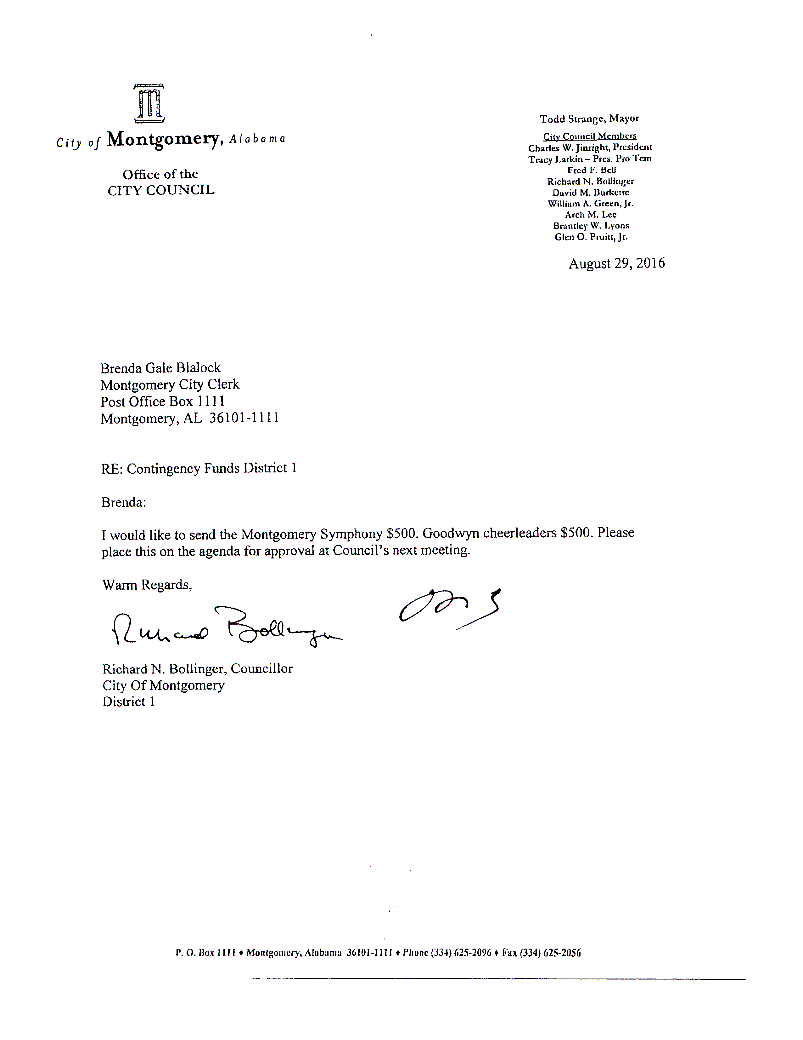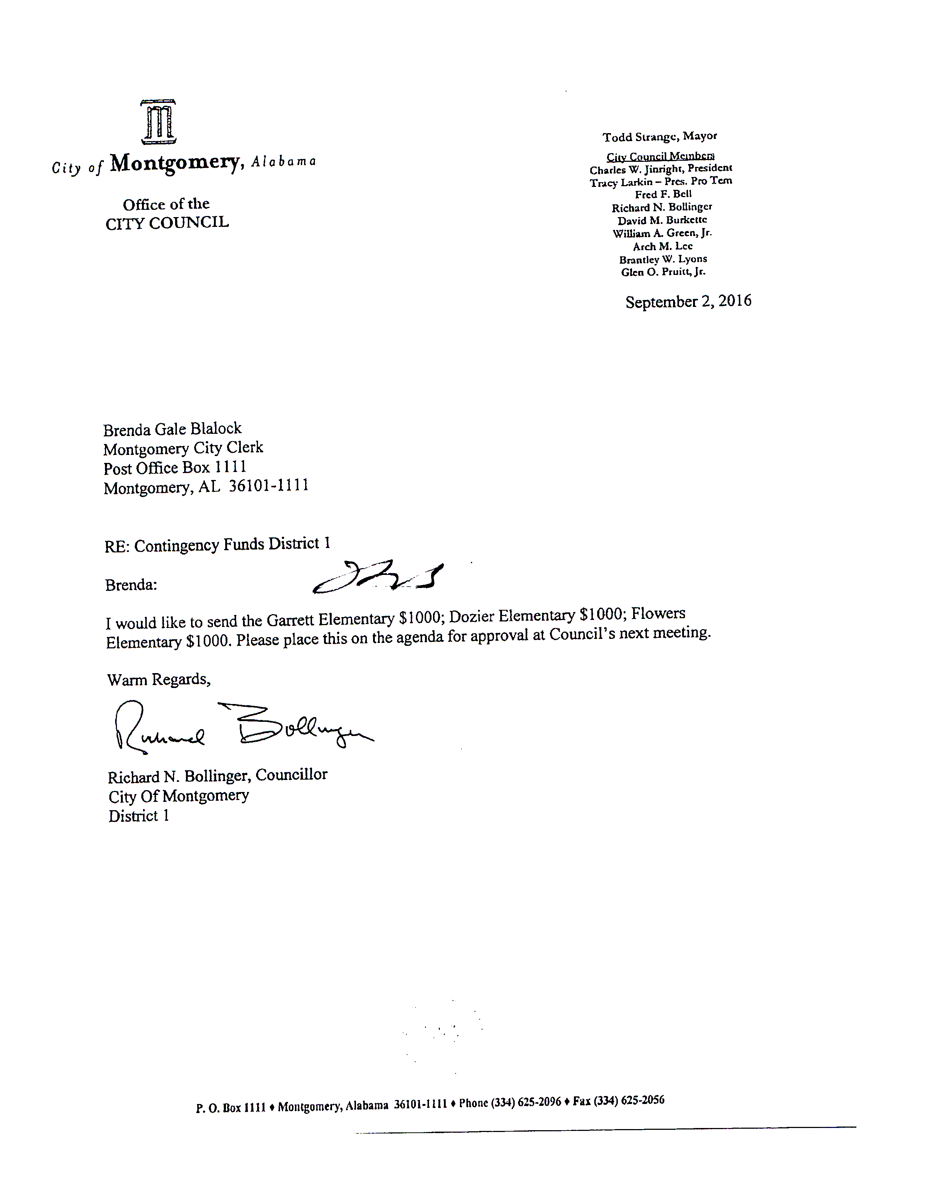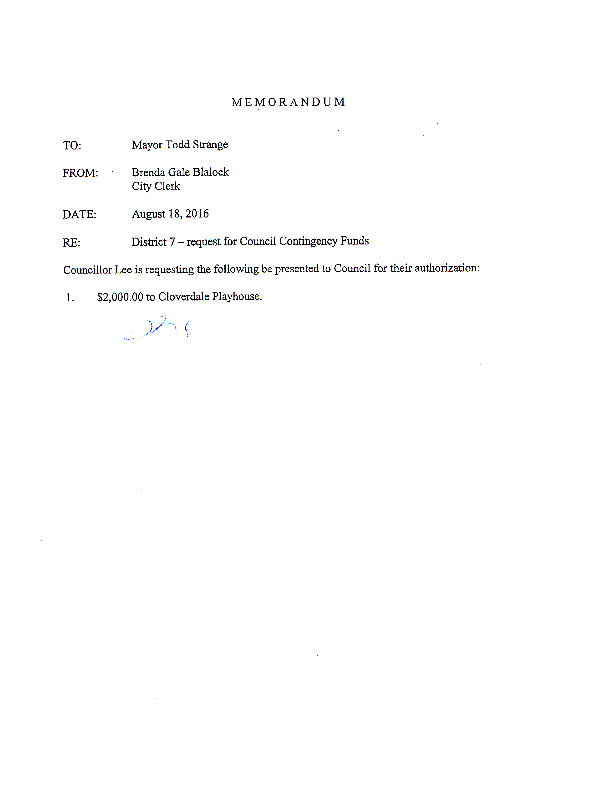

LEFT BLANK INTENTIONALLY

**Councillor Bollinger made a motion to authorize the payment of allocations from the Council Contingency funds, which motion carried with the following vote:**

**AYES: BOLLINGER, LYONS, LARKIN, BURKETTE,**

**GREEN, BELL, PRUITT, JINRIGHT --8**

**NAYS: NONE --0**

**ABSTAINED: NONE --0**

**ABSENT: LEE --1**

**There being no further business to come before the Council, the meeting duly adjourned at 6:14 p.m.**

**/S/**

**BRENDA GALE BLALOCK, CITY CLERK**

**/S/**

**CHARLES W. JINRIGHT, PRESIDENT**

**COUNCIL OF THE CITY OF MONTGOMERY**