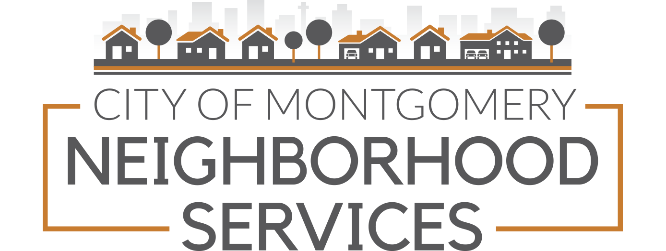

Neighborhood Acknowledgement Form

ASSOCIATION INFORMATION Today’s date
Full name of association (as named in association’s constitution or bylaws)

What is your City Council District?
What is your County Commission District?
What year was your association formed
Your Association represents how many of:
Homes: Businesses:
This organization can best be described as a:
Neighborhood Association…………………………
Homeowners Association (has covenants)…………..
Neighborhood Watch Group ……………………..
Does your association have an IRS Not for Profit designation? ____Yes ____ No
If yes, what is that designation? Ex: 501(c) 3, 501(c) 4, another designation?
Has your association installed neighborhood security cameras? ____ Yes ____ No

NEIGHBORHOOD WATCH PROGRAM
Does your association have a Neighborhood Watch program? ______
If no, would your association be interested in forming a Watch Group?

FOR OFFICE USE ONLY. PLEASE DO NOT WRITE BELOW THIS LINE
Information added/updated: (Initial and Date):
Neighborhood DB Mailing DB
Outlook Email List Outlook Email Groups
Mail Chimp Vendor Update
Other/Notes

GENERAL INFORMATION
Is membership to your association open to everyone within your identified boundaries? If not, explain.
Regular Meeting Date and Time (Example: first Monday of every month at 6:30pm):

Regular Meeting Place (including address):

When are the elections of your officers held? Example: the first Thursday in January each year

Provide a brief statement reflecting the interests and/or concerns of your association.

ASSOCIATION BOUNDARIES
The city/county of Montgomery does not determine the boundaries for your neighborhood association. These are self-defined by your group. If needed, attach a map or written supplement to further describe your area.

STREETS BORDERING YOUR ASSOCIATION’S COVERAGE AREA

ASSOCIATION GOVERNING DOCUMENTS
Please attach a copy of your association’s governing documents. Example: Constitution, By-laws, etc.
If governing documents have been submitted in the recent past and there have been no changes made, they do not have to be submitted again.

ASSOCIATION CONTACT INFORMATION
Information in this section will become part of our mailing and emailing lists. This information will not be shared with or sold to other entities or individuals.

Neighborhood Services preferred communication method is email. We encourage your association to create and actively monitor an account. There are free options for emails such as: Hotmail, Yahoo, Gmail, MSNlive, etc.

Please list officers of the Association. If needed, attach a separate page.
NAME
Office held in association
Address
City, Zip Code
Daytime Phone Other Phone:
Email

NAME
Office held in association
Address
City, Zip Code
Daytime Phone Other Phone:
Email

NAME
Office held in association
Address
City, Zip Code
Daytime Phone Other Phone:
Email

NAME
Office held in association
Address
City, Zip Code
Daytime Phone Other Phone:
Email ______
PRIMARY CONTACT INFORMATION
Direct mail and contacts to (please print):
PRIMARY CONTACT NAME
Office held in association, if applicable
Address
City, Zip Code
Daytime Phone Other Phone:
Email

Sharing contact information is a great way to network and stay informed! Neighborhood Services encourages you to permit us to share your primary contact info with your neighbors who are looking to connect, other neighborhoods, city departments and local organizations when requested. Please check one of the following:

Primary Contact Info may be shared.

Primary Contact info may NOT be shared.

SIGNATURE OF PERSON SUBMITTING INFORMATION TO NEIGHBORHOOD SERVICES
Acknowledgement Completed by (Print Name)
Signature
Title

Updating this form is required immediately following an election if there is a change in officers. If there are no changes to your previous acknowledgement form after your election, please let us know.

This form can be mailed, emailed, or hand delivered to:

NEIGHBORHOOD SERVICES
Attention: Cynthia McCollister
25 Washington Avenue, Suite 510-A Montgomery, AL
Mailing: P. O. Box 1111 Montgomery, AL 36101-1111
Email: cynthia.mccollister@montgomeryal.gov
Phone: 334-625-2175

