**FCS Guardian Kickoff Classic   
Game Day Information**

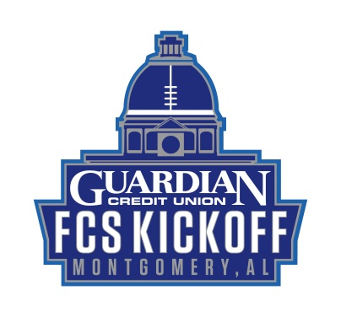

**Road Closures**

* Madison Avenue will close overnight on Friday, August 23rd in front of the stadium, from Jackson Street to Hall Street.
* There will be a hard close from Jackson Street to S. Capitol Pkwy at 10:00 a.m., Saturday, August 24th.
* Streets will reopen overnight, Saturday, August 24th.
* Madison Avenue will be closed from Jackson Street to South Capitol Parkway.
  + Lot K must be accessed by Upper Wetumpka Road. (Pass Required)
  + Lot J must be accessed by Upper Wetumpka Road (Pass Required/Handicap Parking)
* Hall Street will be closed from Adams Avenue to Madison Avenue.
  + Lots A & B may be accessed by Hall Street. (Pass Required)

**Parking**

**Parking LOTS/DECKS open at 10:00am unless otherwise noted**

* Parking Passes are REQUIRED to enter Lots A, B, D, F, G, J and K.
* Lots A and B may be accessed by Hall Street with a pass.
* Lots K & J may be accessed by using Upper Wetumpka Road.
  + Lot J is also designated Handicap Parking
* Four Lots will be available for parking:
  + Tallapoosa Street/Commerce Street (1) – **FREE PARKING**
  + Biscuits Lots on Columbus Street (3) – **FREE PARKING**
* Six Parking Decks downtown will be available for parking:
  + Municipal Deck – Madison Avenue/Court Street
    - **FREE PARKING**
  + Intermodal Deck – Molton Street/Water Street
    - **FREE PARKING**
  + Coosa Street Deck – Tallapoosa Street/Coosa Street
    - **FREE PARKING**
  + RSA-Tower Deck – Monroe Street/Perry Street
    - **Non-Reserved Spaces / FREE PARKING**
  + RSA-Capitol Deck – Madison Avenue/Decatur Street
    - **Non-Reserved Spaces / FREE PARKING**
  + RSA-Union Deck – Madison Avenue/Ripley Street
    - **Non-Reserved Spaces/ FREE PARKING**

**Shuttling (FREE)**

* Begins Saturday at 10 a.m. – Will continue during game, as well as 1.5 hours after game or until all patrons have been picked up/dropped off.
* Pick-Ups/Drop-Off’s Include:
  + Madison Avenue/Hilliard Street
  + RSA-Union Deck
  + RSA-Capitol Deck
  + Municipal Deck
  + Tallapoosa Street/Molton Street
  + Biscuits Lots
  + Coosa Street Deck

**Stadium Security**

* Every patron will be wanded
* No Umbrellas/Long Camera Lenses/Selfie Sticks/Pocket Knives
* Bags must be CLEAR 12x12 or less –Will be **THOROUGHLY SEARCHED**
* Express Lines for those with No Bags
* Multiple Lines will be available at each gate

**RV Parking**

* Lot C is designated for RV Parking
* RV Parking will be available beginning on Friday, August 23, 2019 @ Noon
* Pop-Up Tents are NOT ALLOWED in Lot C
* Pricing:
  + $50 for Electrical Hookups
  + $40 without Power
* Contact:
  + B. Butler at (334) 409-1323 or mgmrvparking@gmail.com

**Reserved Tailgating (Managed by EATSouth)**

* Lot E is designated for Tailgating
* The lot will open at 9 a.m. on August 24, 2019
* $20 per space
* To reserve a space:
  + Email: [info@eatsouth.org](mailto:info@eatsouth.org)
  + Call: (334) 422-9331
* Specify whether you are from Samford or Youngstown State to guarantee a space in the correct section
* No electrical outlets

**Tickets**

* Purchase tickets at [GuardianKickoffClassic.com](https://www.guardiankickoffclassic.com/)
* Tickets will be available for purchase and Will Call tickets can be picked up at Gate 5 at Cramton Bowl on:
  + Friday, August 23rd: 10 a.m. – 5 p.m.
  + Saturday, August 24th: 10 a.m. through the game
    - At all gates beginning at 4 p.m. on Saturday, August 24th
* Youngstown State player passes will be at Gate 4
* Samford University Player Passes will be at Gate 8